Set texts for A Level English Literature
It is your responsibility to buy and read a copy of the following texts.
Please be aware that you will need clean copies for the exam.
Year 1
1. The Duchess of Malfi by John Webster (Norton Critical Editions, ISBN: 978-0-393-92325-4)*
2. Hamlet by William Shakespeare (The Arden Shakespeare, ISBN: 978-1-4725-1838-5)
3. A Thousand Splendid Suns by Khaled Hosseini (Bloomsbury, ISBN: 978-0-7475-8589-3)*
4. Wuthering Heights by Emily Brontë (Penguin, ISBN: 978-0-14-143955-6)*

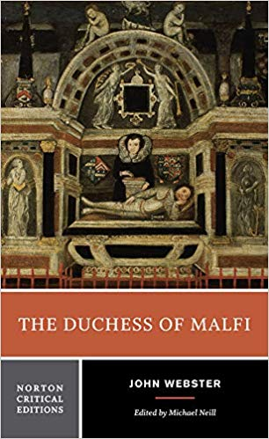
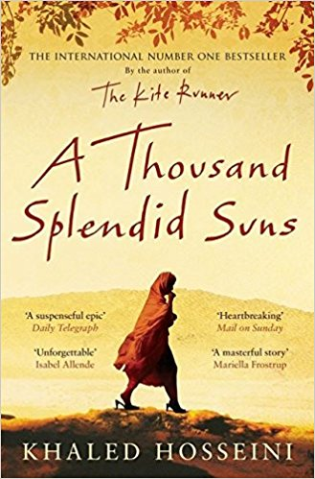

Year 2

- English Romantic Verse (Penguin, ISBN: 0-14-042102-5)

- Regeneration by Pat Barker (Penguin, ISBN: 978-0-141-03093-7)

- The Penguin Book of First World War Poetry (Penguin, ISBN: 978-0-141-18190-5)

* These texts will be covered first.

