

Spanish Taster Lesson links:

**AQA A level Spanish 7692 Syllabus:**

<https://www.aqa.org.uk/subjects/languages/as-and-a-level/spanish-7692>

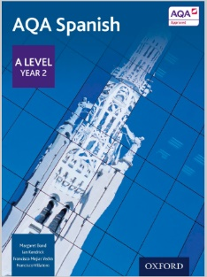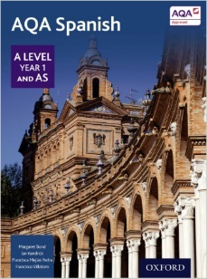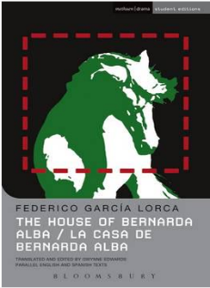

[https://www.amazon.co.uk/Volver-DVD-Penelope-Cruz/def=sr_1_2?dchild=1&keywords=volver+film&qid=1592777586&sr=8-2](https://www.amazon.co.uk/Volver-DVD-Penelope-Cruz/dp/B000TVNR2S/ref=sr_1_2?dchild=1&keywords=volver+film&qid=1592777586&sr=8-2)

<https://www.amazon.co.uk/Level-Year-Spanish-Student-Book/dp/0198366906/ref=sr_1_1?dchild=1&keywords=aqa+spanish+year+1+a+level&qid=1592777536&sr=8-1>

<https://www.amazon.co.uk/House-Bernarda-Alba-Methuen-Modern/dp/0713686774/ref=sr_1_1?crid=14FOZUMBTM89Q&dchild=1&keywords=la+casa+de+bernarda+alba&qid=1592777492&sprefix=la+casa+de%2Caps%2C174&sr=8-1>

<https://www.amazon.co.uk/Level-Year-Spanish-Student-Book/dp/0198366876/ref=sr_1_3?dchild=1&keywords=a+level+spanish+year+2&qid=1592777653&sr=8-3>

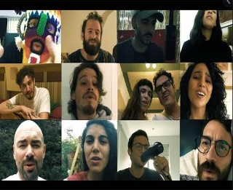

**Si quieres mandarnos el trabajo o tienes algunas preguntas sobre español puedes contactarnos:**

**Aneeka Aziz:** [**aaz@woking.ac.uk**](mailto:aaz@woking.ac.uk)

**Philippe Castagnera:** [**pca@woking.ac.uk**](mailto:pca@woking.ac.uk)

<https://create.kahoot.it/share/woking-college-spanish-taster-day/a836c98c-3cca-461d-b9e7-6506417f54d8>

<https://www.youtube.com/watch?v=JSZqjvCIfzU>

<https://www.youtube.com/watch?v=Y5jwkDM-AQc>