A level English Language & Literature

The Great Gatsby
(1925)
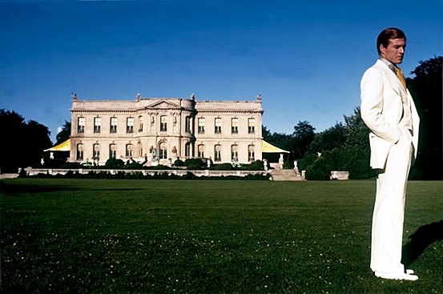

Reading Log

Lessons will begin with the assumption you have all already read this novel. In order for you to make sense of what you have read and for your teacher to check you have indeed read it, you must complete this reading log to hand in during the first lesson of term.

Jot down ideas as you read…and enjoy the decadent and deceitful world of 1920s New York, the infamous eyes of Dr.Eckleburg, unreliable, circumlocutory narration and the unforgettable figure of our tragic hero, Gatsby.

Chapters 1 –5: First thoughts
How are West Egg and East Egg described? Select some key phrases to comment on.

What do we learn of the narrator, Nick Carraway? What role does he play in the story overall?

Note down any instances of social immorality you see – affairs, violence etc.

How are Gatsby’s parties described? Select some key quotations to comment on.

What is the relationship between Daisy and Tom like? What about the relationship between Daisy and Gatsby?

Symbols and Motifs
What is the significance, do you think, of the following (include key quotations as you read)
Telephone calls:

Daisy’s voice:

The eyes of Dr, Eckleburg:

The green light:

Automobiles:

Characters
Summarise, with key quotations and adjectives, the following characters:

NICK:

JORDAN:

DAISY:

TOM:

GATSBY:

