Set texts for A Level English Language and Literature

It is your responsibility to buy and read a copy of the following texts.
Please be aware that you will need clean copies for the exam.
Year 1
1. The Great Gatsby by F. Scott Fitzgerald (Penguin, ISBN: 978-0-14-118263-6)*
2. Stuart A Life Backwards by Alexander Masters (HarperCollins, ISBN: 978-0-00-720037-5)
3. Down and Out in Paris and London by George Orwell (Penguin, ISBN: 978-0-141-18438-8)
4. I Know Why the Caged Bird Sings by Maya Angelou (Virago, ISBN: 978-0-86068-511-1)

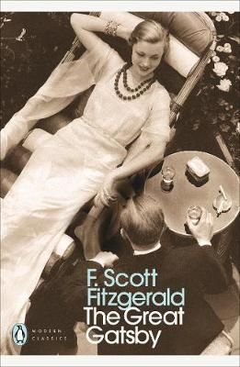
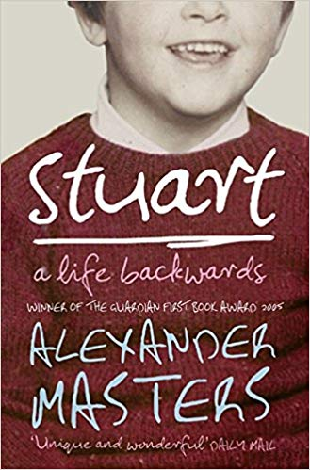

Year 2

- A Streetcar Named Desire (Penguin, ISBN: 978-1-408-10604-4)
* This text will be covered first.

