A Level English Literature Summer Homework –
DUE FIRST LESSON IN SEPTEMBER
Reading Log – A Thousand Splendid Suns, Khaled Hosseini
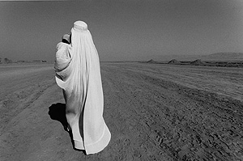
Read the text and make notes under the following categories.
Plot Summary
Part One:

Part Two:

Part Three:

Part Four:

Characters and Key Quotes (make notes and find at least two quotes per category and include page numbers)
Mariam:

Rashid:

Laila:

Tariq:

List other characters you feel are central to plot:

Themes (make notes and find at least two quotes per category and include page numbers)
The Role of Women

Education

Violence/abuse

Relationships
Women/men (husbands and wives; lovers):

Fathers and daughters:

Mothers and daughters -

Friendships – Laila and Mariam

Conflict – religion, politics, war

Hope and disappointment

Are there any recurring images in the text? What might they represent?
Based on your reading of the text, what do you think is the key point or message that the writer is trying to convey?

