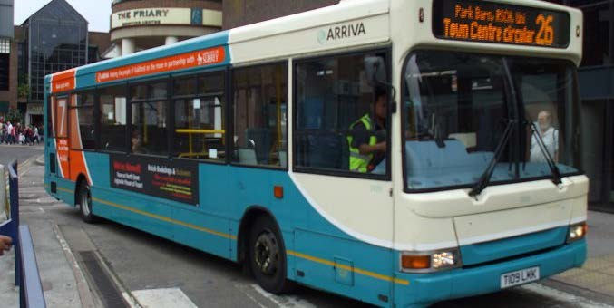
WOKING COLLEGE
How Do I Get To Woking College
From…?

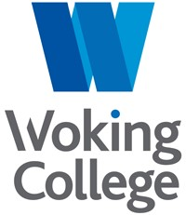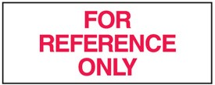
Basic Information

STUDENT FARE CARD SCHEME
The student fare card scheme is for students aged between 16 and 18. It allows travel on buses or trains at reduced rates for journeys to and from college.
The cost of the student fare card is £25 and is valid from 1 September until the end of the following August.
If you need to use both a bus and a train to complete your daily journey, you will need to apply for both a bus and a train student fare card. You can only apply for both cards if both modes of transport are needed to complete your journey. The bus and train cards cannot be used as alternatives to each other.
The application form is available online on the Surrey County Council website: https://www.surreycc.gov.uk/schools-and-learning/schools/school-transport/16transport-to-school-or-college/student-fare-card-scheme from 1 August.
We would remind students that these fare cards take up to six weeks to be delivered to the college so early application is advisable.

BUS AND TRAIN SERVICES
Detailed and up-to-date information on Bus and Train services can be found in the “Guide to Student Travel” document. Please refer to this for any travel queries. The following document is useful only as a rough guide.

How Do I Get To Woking College From…?

Abinger Hammer
Compass Bus 32 to Guildford Bus Station then train to Woking
Addlestone
Cardinal Buses 856 at 0739 from Tesco to Kingfield Green
Albury
Compass Bus 32 to Guildford Bus Station then train to Woking
Aldershot
Train to Woking Station
*Ascot(Berks)
Train to Bagshot then Arriva 34 bus to Kingfield Green
* Students living in “Berkshire” are NOT eligible for a Surrey Student Fare Card
Ash
Stagecoach Kite bus to Guildford Bus Station or Stagecoach bus 3 to Ash Vale, then train to Woking Station
Ash Vale
Train to Woking Station

Ashford
White Bus 446 at 0701 from Staines Bus Station to Kingfield Green or train via Weybridge to Woking Station
Ashtead
Buses Excetera bus 479 to Guildford Bus Station then train to Woking
Bagshot
Arriva bus 34 to Kingfield Green

Bisley
Arriva bus 34 to Kingfield Green
Brooklands
Arriva bus 436 or White Bus 437 to Woking Station
Brookwood
Stagecoach bus 690 at 0745 to Kingfield Green or Train or Buses Excetera bus 28 to Woking Station
Burnt Common
White Bus 462/463 at 0744 to Kingfield Green
Burpham
White Bus 462 at 0739 to Kingfield Green
Byfleet
Arriva bus 436 or White Bus 437 to Woking Station or Train from Byfleet & New Haw to Woking
Camberley
Arriva bus 34 to Kingfield Green

Chertsey
Cardinal Buses 856 from Heriot Road at 0725 or White Bus 446 at 0716 to Kingfield Green
Chilworth
Compass Bus 32 to Guildford Bus Station and train to Woking
Chobham
Falcon Buses 73 at 0745 to Kingfield Green
Clandon
Train to Guildford and change for Woking Station or White Bus 463 from 1005
Cobham
Train to Guildford and change for Woking Station
Deepcut
Stagecoach bus 11 to Farnborough Main Station & train to Woking
Dorking
Train to Guildford and change for Woking Station
Egham
Train to Woking via Weybridge
Englefield Green
First Bus 8 or White Bus 441 to Egham, then train to Woking via Weybridge
Esher
Train to Woking Station
Fairlands
Stagecoach Kite bus to Guildford Bus Station then train to Woking Station
Farnborough
Train to Woking Station
Farnham
Train to Woking Station
Frensham
Stagecoach bus 19 to Farnham Station then train to Woking
Frimley
Train or Stagecoach bus 3 to Ash Vale, then train for Woking Station
Fox Corner
Stagecoach bus 690 at 0724 to Kingfield Green
Gomshall
Train to Guildford then change for Woking Station
Guildford
Train or Arriva 34 bus to Kingfield Green
Hersham
Train to Woking Station or Hallmark Connections bus 458 or 555 to Walton Station then train to Woking
Horsell
Falcon Buses 73 at 0800 to Kingfield Green

Jacob's Well
Arriva bus 34 to Kingfield Green

Knaphill
Arriva bus 34 to Kingfield Green or Arriva bus 91 or Buses Excetera bus 28 to Woking Station
Lightwater
Arriva bus 34 to Kingfield Green
Merrow
Arriva bus 37 to Burpham and then White Bus 462 to Kingfield Green, or White Bus 463 direct to Kingfield Green from 1000
New Haw
Cardinal Buses 856 at 0744 from White Hart or at 0749 from Black Prince to Kingfield Green
Normandy
Stagecoach Kite bus to Guildford Bus Station then train to Woking Station

Ottershaw
White Bus 446 to Kingfield Green

Pirbright Village
Stagecoach bus 690 at 0730 to Kingfield Green or Buses Excetera 28 at 0738 to Woking Station (and all from Pirbright Camp a few minutes later)
Pyrford
White Bus 437 to Woking Station
St Johns
Stagecoach bus 690 at 0802 or Arriva bus 34 to Kingfield Green
Send
White Bus 462 at 0749 to Kingfield Green
Sheerwater
Cardinal Buses 856 at 0756 to Kingfield Green, or Arriva 436/ Falcon Buses 456 to Woking Station

Shepperton
Cardinal Buses 856 at 0714 from Green Lane/Station Approach to Kingfield Green, or Hallmark Connections bus 458 or 555 to Walton Station then train to Woking

Staines
White Bus 446 at 0701 from the Bus Station to Kingfield Green, or Train to Woking via
Weybridge
Stoughton
Arriva bus C or Stagecoach bus 2 to Guildford Bus Station then train to Woking Station, or Arriva bus 34 to Kingfield Green from Woking Road/Stoughton Road
Sunbury
Cardinal Buses 856 at 0702 from Sunbury Cross to Kingfield Green
Sutton Green
Arriva bus 34 to Kingfield Green
Tongham
Stagecoach bus 3 to Ash Vale Station and train to Woking (from 18 February 2019, the nearest point to Tongham served by bus 3 will be Shawfield Road in Ash)
Upper Halliford
Cardinal Buses 856 at 0706 to Kingfield Green
Virginia Water
Train to Woking via Weybridge
West Byfleet
Train to Woking Station, or Arriva bus 436, White Bus 437 or Falcon Buses 456 to Woking Station
West End
Arriva bus 34 to Kingfield Green
Weybridge
Train to Woking Station, or Arriva bus 436 to Woking Station
Windlesham
White Bus 500 to Lightwater, then Arriva bus 34 to Kingfield Green
Woodham
Cardinal Buses 856 at 0751 from The Victoria to Kingfield Green
Worplesdon
Stagecoach bus 690 at 0720l to Kingfield Green

Wych Hill
Buses Excetera 28 to Woking Station

For bus information, including contact details for operators or for up to date timetables of all services, advance news of future changes etc., go to www.surreycc.gov.uk/buses
Alternatively, there is the Traveline website and journey planner tool on www.traveline.info/se or call 0871 200 2233 open 0700-2200 (calls cost 12p per minute plus phone company's access charge)

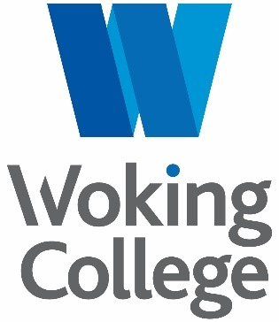
Rydens Way, Woking, GU22 9DL
01483 761036 wokingcoll@woking.ac.uk www.woking.ac.uk

